**PROJECT REPORT**

###### NATIONAL INSTITUTE OF TECHNOLOGY, AGARTALA



##### OPTIMIZATION BASED APPROACH TO DETERMINE OPTIMAL SITE AND SIZE OF ELECTRIC VEHICLE CHARGING STATIONS FOR NORTH-EAST CITY AGARTALA, TRIPURA, INDIA

UNDER THE GUIDANCE OF

**Dr. AJOY KUMAR CHAKRABORTY**

(Department of Electrical Engineering)

.

##### 

##### PREPARED BY:

|  |  |  |  |  |
| --- | --- | --- | --- | --- |
| JAYESH MAHAWER - | | (17UEE060) | | |
| MAYANK GUPTA - | | (17UEE051) | | |
| ASHUTOSH AIRY - | | | (17UEE097) | |
| UDITA DEBBARMA - | | (17UEE073) | | |
|  | |  | | |
|  | |  | | |



**CERTIFICATE OF APPROVAL**

##### This is to certify that the report entitled “OPTIMIZATION BASED APPROACH TO DETERMINE OPTIMAL SITE AND SIZE OF ELECTRIC VEHICLE CHARGING STATIONS FOR NORTH-EAST CITY AGARTALA, TRIPURA, INDIA” is submitted by: -

|  |  |  |
| --- | --- | --- |
| JAYESH MAHAWER - | (17UEE060) | |
| MAYANK GUPTA - | (17UEE051) | |
| ASHUTOSH AIRY - | | (17UEE097) |
| UDITA DEBBARMA - | (17UEE073) | |

is examined and accepted in fulfilling the requirement for the award of Bachelor of Technology degree in Electrical Engineering at National Institute of Technology, Agartala.

BOARD OF EXAMINERS

**----------------------------------------------------**

**----------------------------------------------------**

SUPERVISOR(S)

-----------------------------------------------------

CHAIRMAN

-----------------------------------------------------

DATE: - PLACE: -

**DECLARATION**

We do hereby declare that the work, which is presented in this project, entitled as --

**“OPTIMIZATION BASED APPROACH TO DETERMINE OPTIMAL SITE AND SIZE OF ELECTRIC VEHICLE CHARGING STATIONS FOR NORTH-EAST CITY AGARTALA, TRIPURA, INDIA”** is submitted for the partial fulfillment of the requirements for the award of Bachelor of Technology in the DEPARTMENT OF ELECTRICAL ENGINEERING of NIT Agartala.

This is an authentic record of the work carried out under the supervision of **Dr. AJOY KUMAR CHAKRABORTY** Department of Electrical Engineering, NIT Agartala.

The matter embodied in the report has not been submitted by us to any other University /Institute for the award of any Degree.

JAYESH MAHAWER (17UEE060)

---------------------------

MAYANK GUPTA (17UEE051)

---------------------------

ASHUTOSH AIRY (17UEE097)

----------------------------

UDITA DEBBARMA (17UEE073)

----------------------------

**CERTIFICATE OF RECOMMENDATION**

I hereby approve and forward the project entitled “**OPTIMIZATION BASED APPROACH TO DETERMINE OPTIMAL SITE AND SIZE OF ELECTRIC VEHICLE CHARGING STATIONS FOR NORTH-EAST CITY AGARTALA, TRIPURA, INDIA”** carried out and recommend that the stage 1 of this project work can be accepted in fulfilling the requirements for the course of Bachelor of Technology in Electrical Engineering.

----------------------------------------------

Dr. AJOY KUMAR CHAKRABORTY,

Associate Professor,

Department of Electrical Engineering,

NIT Agartala

**ACKNOWLEDGEMENT**

###### We would like to thank all, whose help was inevitable in the successful completion of this Project.

First of all, we would like to thank our Project Guide ***Dr. AJOY KUMAR CHAKRABORTY*** under whose skillful guidance we have learned all we could and have started our project work. We would also like to thank Department of Electrical Engineering, NIT Agartala for allowing and motivating us to work on our project.

Our thanks and appreciations also go to the people who have willingly helped us out with their-ablility.

## INDEX

|  |  |  |  |
| --- | --- | --- | --- |
| S.N. |  | Particulars | Page No. |
| 1 | Ch-1 | Introduction | 01-04 |
|  | 1.1 | Issues and challenges | 01-03 |
|  | 1.2 | Literature review | 03-04 |
|  | 1.3 | Motivation | 04 |
| 2 | Ch-2 | Theory and modeling of electric vehicle charging stations | 05-17 |
|  | 2.1 | Introduction | 05 |
|  | 2.2 | Station location approach | 05-06 |
|  | 2.3 | Charging needs | 06-09 |
|  | 2.4 | Charging coverage | 09-13 |
|  |  | 2.4.1 Instant coverage | 09-10 |
|  |  | 2.4.2 Personal charging access | 11-12 |
|  |  | 2.4.3 Charging coverage | 12-13 |
|  | 2.5 | Adoption potential | 13-17 |
| 3 | Ch-3 | Optimization formulation to obtain optimal site and size of electric vehicle charging stations for north-east city Agartala, Tripura, India | 18-32 |
|  | 3.1 | Introduction | 18 |
|  | 3.2 | Problem formulation | 18-30 |
|  |  | 3.2.1 Optimization problem for obtaining optimal sites of charging stations | 18-25 |
|  |  | 3.2.2 Optimization problem for obtaining optimal size of EVCSs | 25-28 |
|  |  | 3.2.3 Solving proposed formulation | 28-30 |
|  | 3.4 | Optimization results | 30-31 |
|  | 3.5 | Result analysis | 32 |
| 4 | Ch-4 | Conclusion | 33 |
| 5 |  | References | 34-37 |

**Chapter-1**

***INTRODUCTION***

Since ages, humans have invented millions of technologies. An invention is widely spreaded until a better, and cheaper technology comes into story. From using gasoline to drive a car, humans have come a very long way in the science of vehicle, and nobody knows what future will offer us.

Limited amount of fuels, increasing pollution, global warming, increasing price and many other factors are the reasons why electric vehicle is the necessity of today. Fully electric vehicles are very efficient from an energy standpoint, and have a great potential for promoting the use of local renewable sources of electricity. The improvement in charging facilities will determine the establishment and well going of electrical vehicles, which will determine scale of Electrical Vehicle (EV) development and applications.

There are many programs are running worldwide for installing charging stations considering EVs charging demand, user behaviour patterns, road network structure, cost of charging station construction and operation, location of charging station.

This article presents a new approach to determine the optimal location and capacity of public charging stations (CSs) , where the specificities budget constraints, station coverage, adoption potential and many more are taken into account.

* 1. **WHAT IS EV?**

An electric vehicle (EV) is one that operates on an electric motor, instead of an internal-combustion engine that generates power by burning a mix of fuel and gases. The electric motor may be powered by a collector system by electricity from off-vehicle sources or using self-contained chargable battery, solar panel, fuel cell, and electric generator.

* 1. **TYPES OF EV**

1. Battery electric (BEV)
2. Hybrid electric (HEV or hybrids)
3. Pug-in hybrid electric (PHEV)
4. Fuel cell electric (FCEV)



* 1. **TYPES OF BATTERY USED IN EV:**

1. LITHIUM-ION BATTERY
   * Lithium Iron Phosphate Oxide (LiFePO 4) or simply called LFP for Lithium Ferro Phosphate
   * Lithium Nickel Manganese Cobalt (LNMC) or popularly known as NMC
   * Lithium Titanate Oxide (LTO)
2. NICKEL-METAL HYDRIDE BATTERY
3. LEAD-ACID BATTERY
   1. **Battery Parameters To Consider**
4. Life span
5. Safety
6. Cost
   1. **CHARGING STATION INFRASTRUCTURE**
7. A electric vehicle charging station (EVCS) is a machine that supplies electric energy for the recharging of self-contained electric battery.
8. The EV charging infrastructure comprises of the following:

* Electricity supply infrastructure - transformers, meters, panels, conduits and wires that is required to provide reliable electricity supply to the vehicle chargers.
* Electric Vehicle Supply Equipment networking requirements to enable efficient EV charging and other services among EVSE owners and EV drivers
* EVSE and EV integration for automated communications and EV identification
* EVSE/EV communication with electricity service provider and/or grid operators for effective monitoring and management of EV, as a grid resource

1. The EVSE current follows are categorized as :

* Alternate current (AC) charging : Charging with AC is used for low- and medium-power charging at homes and offices or workplaces, and at public space.
* Direct current (DC) charging : Charging with DC is used for fast-power and are called DC Fast Charging (DCFCs).
* AC Pulse Charging (ACPC) : It is enabled through the deployment of Ultra Capacitors. These chargers are typically deployed on heavy duty vehicles (buses and trucks) mostly through the use of pantograph style connectors due to the heavy pulsed charging currents involved

1. In the AC EVSEs the converter is on-board the EV, while the DC EVSEs (DCFC) and the ACPC (AC Pulse Chargers) have integrated converters.
   1. **CHARGING LEVELS OF EV**



* 1. **MODELING OF ELECTRIC VECHICLE CHARGING STATIONS**
* ***COMPONENETS OF EVCS***

1. Power source;
2. Three-phase electric power;
3. Charging points;
4. Masters;
5. Server with database;
6. Asynchronous serial connections;
7. Communication TCP/IP (Transmission Control Protocol/Internet Protocol);
8. Slaves.

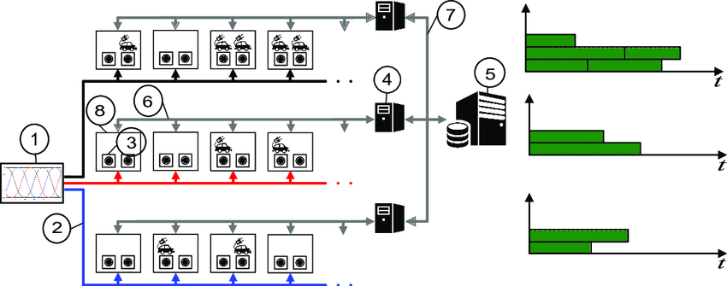

* As shown in Figure, the station is controlled by a server together with a number of masters and slaves.
* Each slave controls two charging points of type 2/AC IEC 62196-2. A master is connected to eight slaves and has a user interface.
* The server centralizes the control and receives signals from the slaves regarding events as connection or disconnection of EVs.
* The server also sends orders to the slaves to activate and deactivate charging points in accordance with the schedule. Even though there are many spaces available not all the charging points in these spaces can be active at the same time due to the available power being limited.
* For example, if electricity supply of 50 kW three phase power (3/AC) were contracted and each EV requires 7.3 kW, at most 21 EVs can be charging simultaneously in a line at the maximum power. To avoid energy losses, the imbalance among the three lines must be limited. To this end, a hard maximum imbalance between every two lines is established.
  1. **VEHICLE GRID INTEGRATION (VGI)**

1. The use of vehicles to deliver the grid services are collectively referred as Vehicle-Grid Integration (VGI).
2. Bi-directional flow of electricity enables a V2G capable vehicle to discharge its battery power to the grid and provide grid services whenever it is plugged-in and communicating with the grid.
3. **SERVICES PROVIDED BY EV TO GRID WITH VGI:**

* Ancillary services such as:
* Peak power shaving : Injection of active power stored in the batteries of EVs during peak load hours can help lowering the peak power demand of the distribution system.
* Spinning reserve : Provided by online generators that can change their output instantly in response to major transmission outages.
* Voltage and frequency regulations
* Reactive Power Regulation
* Integration of large scale renewable energy sources (RES)

1. **EFFECT OF EV ON THE GRID:**

* Coordination of several vehicles
* Impact of vehicle range
* High costs of upfront infrastructure
* Peak load impacts of uncontrolled charging
* Local distribution system impacts from clustering of EV
* Billing issues
* Structuring of battery warranty and the compensation model
* Utility ownership of EVSE

1. **MOTIVATION FACTORS:**
   * The bidirectional power flow feature of EVs is promising for Utilities for two main reasons:

* for storage and balancing for intermittent renewable energy and
* for providing grid support/ancillary services

1. **DISADVANTAGES:**

* The initial investment is steep.
* Some EVs have short ranges for driving.
* Charging of an EV can take a lot of time.
* Charging stations aren’t available everywhere.
* Proper allocation of charging station is required in order to reduce its negative impacts in various aspects.
* Huge penetration of EV makes stress on electrical distribution system and impact on grid.

1. **COMPONENTS FOR V2G:**
   1. Point of grid interconnection
   2. EVSE : Bidirectional EV Supply Equipment (EVSE or EV Charger) which can be optimally designed for providing support to the grid during critical conditions
   3. EV and the BMS (Battery Management System) that manages the operations.
2. **COMPONENTS OF A VGI :**
   1. V2G CAPABLE VEHICLE
   2. BATTERY
   3. BATTERY MANAGEMENT SYSTEM (BMS)
   4. BATTERY CHARGER (AC-DC) & INVERTER (DC-AC)
   5. CONTROLLER, GPS & ELECTRICITY METER



* 1. **IEEE 33 BUS BAR DISTRIBUTION SYSTEM**



* 1. **LITERATURE REVIEW:**

**Optimal location approach [1] includes four stages:**

1. The first consists in estimating charging needs of a standard Battery Electric Vehicle (BEV);
2. The second consists in evaluating how these needs can be covered through public charging stations;
3. The third consists in estimating the target market for BEV; and
4. The fourth and final consists in merging the information coming from the previous stages into an optimization model for determining the locations of charging stations.

The key factor that affects the location and size of a charging station such as *budget constraints, station coverage, adoption potential* and many more are given in [3]. The challenges pertaining to EVs energy storage technologies are studied [15],[16] and [17] and further discussions about their adoption can be found in [11] and [20] . The instant coverage concept measures whether a given zone is within an acceptable walking distance of the nearest public charging station / parking place is given by [31].

**From the literature following are observed:**

1. Very less work considered the objective function of charging coverage which needs to be maximize in order to get optimised location subject to some decision variables, parameters and constraints.
2. As the adoption of EVs of any zone increases the coverage of charging station also increases. So we must locate our charging station based on adoption potential of locality and the population in that area.
   1. **ISSUES AND CHALLENGES**

Researchers are facing many issues and challenges to find out the optimal locations of Electric Vehicle Charging Stations (EVCSs). Some of the important issues and challenges are discussed below:

* Finding the optimal locations for EV CSs in urban areas.
* Determining the charging demand of the Charging Stations (CSs), which is mainly, depends on the expected number of EVs that use a CS during the peak hours.
* How to utilize the free public spaces in order to place charging stations, the charging station development cost mainly consists of an equipment cost and a land cost.
* Increasing the EV drivers’ convenience. Because the proper distribution of the charging stations increases available choices for the electric vehicle drivers’ to charge their vehicles, as well as decrease the charging process time. EV drivers prefer to charge their vehicle as fast as they can, because they do not like to stay in queues in the charging stations.
* Considering the cost of the grid operator.
* What are the preferred times for the EV drivers to charge their vehicles?
* The distance between the selected charging stations and the power grid must be taken into account. The charging station must be connected to the substation via dedicated feeder, and the electrification cost of the charging station depends on the cross section and the length of the dedicated feeder.
* External factors that may affect the reaching to the charging stations, such as the condition on road networks, the weather on the area, the geographical characteristics of the location of the charging stations such as the height of the CS position, and considering the existence of previous charging stations that have been placed at the same area.
  1. **MOTIVATION**

This project aims to answer the following questions:

* Where should charging stations be deployed along the city to support worry-free EV travel in intra-city or intercity?
* How many charging outlets must be built at each station?

In view of the above, the main motivations behind the work carried out in this project have been the following:

To ensure worry free inter cities or intra-city EVs travel, frame work proposed in [1] and [2] is used for case study to identify location for charging stations in area of 45 km2 in Agartala Suburbs .The area is divided in thirteen zones.

* To optimize the size of charging station with the help of objective function to minimize the integrated cost of the Investment and operation. Initially, number of EVs in target area have been fixed. Problem has been solved using python programming by importing puLP package.
* Though the overall project seeks to ensure worry-free EV travel model throughout Agartala, this first phase seeks to determine optimal placement of charging stations to make EV travel in between Agartala cities, or inter-city travel, feasible. It seeks to also minimize total investment cost.

**sChapter-2**

***THEORY AND MODELING OF ELECTRIC VECHICLE CHARGING STATIONS***

**2.1 INTRODUCTION**

This chapter focus on the latest proposed approaches pertaining to EVCSs. The proposed techniques are summarized in terms of the objective functions, and the solutions methods that have been implemented in order to find the solution of the problem. Furthermore, issues and challenges that are commonly confronted during working on determining the best location and capacity of charging stations discussed.

**2.2 STATION LOCATION APPROACH**

The proposed station location approach comprises four stages:

1. The first consists in estimating the charging needs of a standard BEV;
2. The second consists in evaluating how these needs can be covered through public charging stations;
3. The third consists in estimating the target market for BEV; and
4. The fourth and final consists in merging the information coming from the previous stages into an optimization model for determining the locations of charging stations.

The approach is summarized in Figure 2.1.

* In the first stage, the BEV charging needs are defined as the charging demands to be served. First, the main energy storage and charging systems available are examined and compared from the technological and market viewpoints, in order to select the most suitable one for urban areas. Secondly, the typical energy requirements for urban trips are evaluated assuming that trip patterns are not dependent on vehicle technology (BEV vs. ICE). Finally, the combination of the selected energy storage and charging system with the energy requirements allows the estimation of the daily average and potential (maximum) charging needs of a BEV driver.
* In the second stage, the charging coverage concept is applied to assess how the charging needs of BEV drivers are satisfied through a public charging network. First, the access of users to charging stations is evaluated in terms of walking access distance (instant coverage). Next, this access is measured for the different places where a driver typically parks along a day under the concept of personal charging access (thus adding the time dimension). Afterward, the contribution of home charging as a complement to the public charging network is dealt with. Finally, the charging coverage concept assesses the satisfaction of potential charging needs as a function of personal charging access.

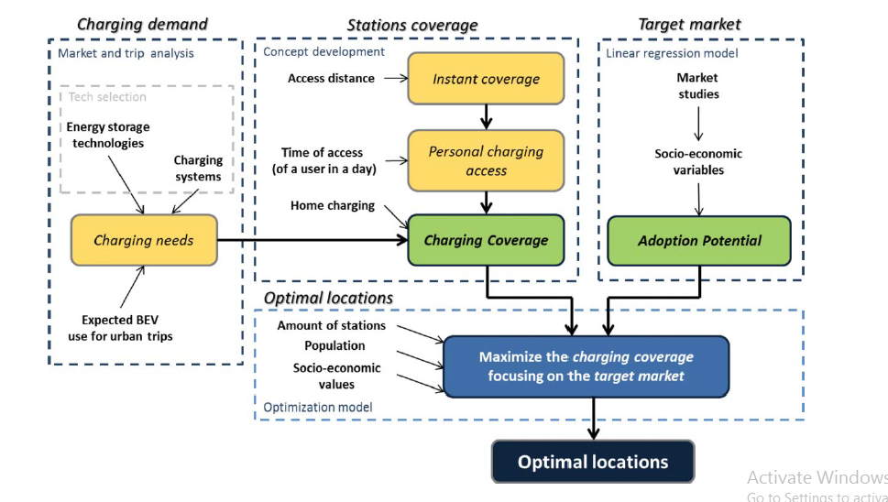

Figure 2.1. Station Location Approach

* In the third stage, the target market for BEV is estimated under the concept of adoption potential, based on the results obtained for studies where the willingness to adopt BEV (or other environmentally friendly vehicles) is related with the socioeconomic characteristics of populations.
* Finally, in the fourth stage, a location-allocation model is applied to determine the BEV charging network that maximizes the charging coverage of users weighted by their adoption potential (target market). The inputs of the model are the number of stations to locate (which is a function of the budget available for installing stations), the number of residents and the number of jobs in each zone of the urban area under analysis, the level of shopping and leisure activities of the zones, and the values for some socioeconomic characteristics (education, income, etc.) of the population of zones. The outputs of the model are the locations of the stations and the demand served by each station.

**2.3 CHARGING NEEDS**

To define the energy requirements to be satisfied by the charging network, the charging system and expected urban uses of electric vehicle are briefly examined in this section. The most convenient midterm on-board energy storage technology is selected from a comparison of alternatives, and the available charging systems for that technology are assessed in view of the identification of the most suitable for urban areas. Then, the expected daily energy requirement of electric vehicles for urban trips is estimated. Combining these requirements with the selected charging system, it is possible to define the average and the potential (maximum) charging needs to be supplied by the charging stations in terms of recharge time per day and per car.

The main challenge of electric vehicles lies on the onboard energy storage technology. In this respect, a crucial issue is to find an economic balance between storage capacity (energy density), storage performance (recharge time, power, and life span), and storage cost.

There are four main types of energy storage technologies for electric vehicles:

* Electrochemical batteries,
* Ultra-capacitors,
* Fuel cells, and
* Fly-wheels.

According to these studies, ***electrochemical batteries*** are the most convenient technology to implement electrical mobility in the midterm. This is mainly because electrochemical batteries have the most balanced characteristics, even considering their long recharge times, which in the case of urban uses are feasible to handle (if the recharging process is smartly managed).

Instead, ultra capacitors and flywheels have fast recharge times but their cost is high and energy density is low.

Fuel cells are a promising alternative with higher energy density, but are still in an immature state with very high costs and the requirement of a complex dedicated infrastructure.

There are three types of commercially available charging systems for BEV:

* Slow charging,
* Fast charging, and
* Battery swapping

**Slow charging** is the preferred and recommended system by auto manufacturers.

This type of charging system offers a series of advantages over the rest: It is the best with respect to battery lifespan; requires a simple installation easy to set up at home; has the smallest energy transmission losses; and can use electricity directly from the grid without significant impacts. The main limitation of slow charging is precisely the considerable amount of time needed to recharge the batteries.

**Fast charging** has negative implications on the battery lifespan and on the grid.

**Battery swapping** virtually eliminates recharge times but requires the standardization of batteries, which will not be easily accepted by auto manufacturers, as well as a stock of idle batteries (the most expensive component of a BEV).

Though fast charging and battery swapping are not likely to become the main charging systems of every day, they are seen as useful alternatives for long interurban trips or for very heavy urban uses.

No matter the charging system, all the options are based on charging stations. Given the relatively fast recharge times of fast charging and battery swapping, the location of the respective stations can be managed similarly to the location of conventional gas stations, but considering the more limited autonomy of the vehicles. Slow charging, instead, cannot be expected to happen in the middle of a trip because of the considerable recharging times it requires, being better suited to occur during long parking times (e.g., near home during the night or near workplace during the day).

Taking BEV and slow charging to be the most convenient solutions for urban areas, an important issue to consider relates to the autonomy of commercially available BEV. Most of these vehicles have ranges from 100 to 200 km in ideal conditions, which in urban conditions are reduced to approximately 80 to 160 km. A full charge of these vehicles varies from 3.5 to 9 h of slow charging, depending on the size of the batteries (which is directly related to the autonomy range) and on the power output of the charger (which can vary widely from vehicle to vehicle). In the case of a public charging station it is expected that recharge time will not exceed 8 h.

According to a Eurostat study, Europeans make on average three trips and travel between 30 and 40 km per day .Passenger cars account for approximately 70% of their trips, and the average commuting distance is from 6 to 8 km, which is approximately one quarter of the total average daily distance. This distance includes long distance trips and refers to modes other than car, suggesting that in the specific case of cars and intra urban travel, the length travelled will be significantly shorter. Therefore, it can be assumed that an autonomy range of 40 km will cover the great majority of BEV urban trips and the energy required for this range can be usually delivered in 2 to 3 h. Hence, 3 h can be taken as the average charging needs of a typical BEV user.

While fast charging networks are not developed, it is not expected that a BEV will be used to make daily distances higher than the autonomy of higher range BEV (160 km), or two times the autonomy of lower range BEV (80 km) at most. This limitation is because of the considerable required recharging time and is also encouraged by the “range anxiety” phenomena. In both cases, a maximum daily recharging time of 8 h is required. This time can therefore be taken as the potential (maximal) charging needs of a BEV.

**2.4 CHARGING COVERAGE**

The way how charging requirements of drivers are satisfied by a public charging network is assessed through the concept of charging coverage. This concept is progressively introduced, starting with the related concepts of instant coverage and personal charging access.

The charging coverage concept is defined for a geographic area divided into small zones for which demographic and socioeconomic data is available, as is the case of census units or blocks. The small zones are represented by a point (e.g., the centroid). The possible locations of charging stations are assumed to be known and may coincide with some (or all) of the points representing the zones into which the geographic area is divided.

The capacity of charging stations is not taken into account in the determination of charging coverage (un-capacitated coverage). In the short term and midterm, station capacity issues do not seem to be of major importance for the design of a charging station network. Currently, most of the deployment plans precede real demand in order to promote it. In the longer term, when the BEV market will be more mature, an update of the approach addressing capacities issues may be necessary.

**2.4.1 INSTANT COVERAGE**

The instant coverage concept measures whether a given zone is within an acceptable walking distance of the nearest public charging station / parking place (through the shortest possible network path. If this condition is achieved, then the zone is considered to be instantly covered.

In the former, two cities in the Netherlands were analysed, a small one and a large one, and the optimal stop spacing were found to be 600 and 800 m respectively (meaning that any individual living next to the bus route would have a stop within a distance of 300 and 400 m).

Coverage starts to decay significantly for walking distances above 200 or 300 m, is relatively small after 400 or 500 m, but is not null until distances are as large as 1,400 m.

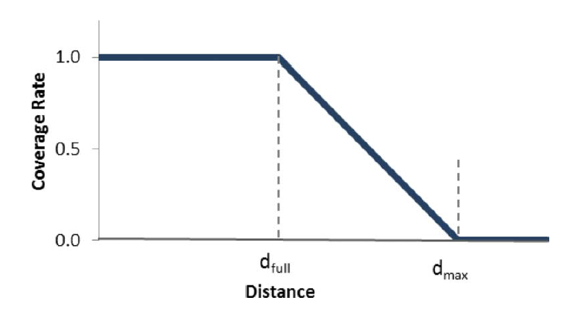

Figure 2.2: Instant Coverage Function

To define a coverage function of three segments (Figure 2.2):

* a first segment expressing a coverage rate of 1 (100%) for distances below the (maximal) full coverage distance (dfull);
* a second segment expressing a linear coverage rate decay, from 1 to 0, between the full coverage distance and the maximal (partial) coverage distance (dmax); and
* a third segment expressing no coverage for distances higher than the maximal coverage distance.

That is:

..............(2.1)

**Where:**

* N : set of zones,
* S : set of possible charging station locations,
* cis : coverage rate for zone i with a charging station located at s,
* dis : distance from zone i to a charging station located at s.
* dfull : full coverage distance,
* dmax : the maximal (partial) coverage distance,
* The instant coverage of zone i (vi) is taken to be the coverage rate provided by the nearest charging station.

**2.4.2 PERSONAL CHARGING ACCESS**

The personal charging access concept refers to the average proportion of daily time during which a BEV driver has access to charging stations. The time dimension is added to the concept of instant coverage defined above in order to later evaluate the response of a charging network to charging requirements. If the daily trips of an individual are done by car, the recharging times and locations essentially correspond to parking times and locations, which are closely related with the distribution of population activities over the day.

In general, home and work are the only places where BEV drivers can completely fulfil their average daily charging needs, as the time spent on average in other places (mainly because of shopping and leisure activities) is much shorter.

The computation of personal charging access for an individual residing in zone i and working in zone j, wij, with a specific distribution of daily activities (home, work, and others), can be made through the following expression:

…………. (2.2)

Where:

: average proportion of time spent at home,

: average proportion of time spent at work,

: average proportion of time spent in other places,

: instant coverage at home (zone i),

: instant coverage at work (zone j),

average instant coverage in places other than home or work for individuals residing

in zone i and working in zone j.

is weighted by their respective attractiveness indexes; that is:

………… (2.3)

Where:

: attractiveness index of zone k for individuals residing in zone i and working in zone j,

instant coverage for zone k.

The attractiveness index for each zone should be defined, taking notably into account the level of shopping and leisure activities available in the zone.

For the average European, according to Eurostat information, fH = 0.62, fW = 0.25, and fO = 0.13, therefore the personal charging access is given by:

…………… (2.4)

For BEV users who can charge their vehicles at home, public charging stations normally will only provide coverage when they are working or doing other activities.

Hence, for these users, vi = 1, and personal charging access can be expressed as follows:

…………. (2.5)

**2.4.3 CHARGING COVERAGE**

The personal charging access concept is an indicator of the level of access of BEV drivers to charging stations. However, it is important to understand what this level of access actually signifies for the satisfaction of their charging needs, in order to establish a measure of charging coverage.

Since there is no empirical information about how drivers appraise their levels of access to charging stations, the charging coverage measure will be developed based on four logical assumptions:

1. The **first one** is that if the potential charging needs of a prospective BEV driver are not satisfied (as his or her time of access to charging stations is not enough to make one full charge over a day), then he or she will not be (significantly) covered and will not acquire the vehicle. Thus, no charging coverage is achieved with a personal charging access lower than the potential charging needs.
2. A **second assumption** is that if potential charging needs are fulfilled, then charging coverage is considered to be good (the BEV driver is well covered). However, the level of access to charging stations will be improved if the driver has more options when deciding where to refuel his or her vehicle.
3. The **third assumption** is that access to more than the potential charging needs progressively adds satisfaction to the user and signifies a better charging coverage, up to the point where the driver can charge the vehicle whenever it is parked (the BEV driver is fully covered and his or her personal charging access is equal to 1).
4. Finally, the **fourth assumption** is that it is possible to set a trade-off ratio (r) between the level of satisfaction of a well-covered driver and the level of satisfaction of a fully covered driver.

A value of r = 0.8 signifies that well-covered drivers are 20% less satisfied than fully covered drivers or, what it is the same, 10 well-covered drivers are equivalent to eight fully covered drivers in terms of coverage objectives.

In sum, drivers who have access to charging stations whenever their vehicle is parked are fully (100%) covered; drivers who have access just the time necessary to make one full charge a day (8 h) are well covered, with their satisfaction being r% of the maximum possible; and drivers who do not have access to a charging station at least the time to make one full charge a day are not covered.

Under these assumptions, the charging coverage of a driver residing in zone i and working in zone j can be expressed by the following function (reference figure:- Figure 2.3):

………. (2.6)

Where:

: trade-off ratio,

: personal charging access for population residing in zone i and working in j, and

: potential charging needs expressed as a proportion of total daily parking time.

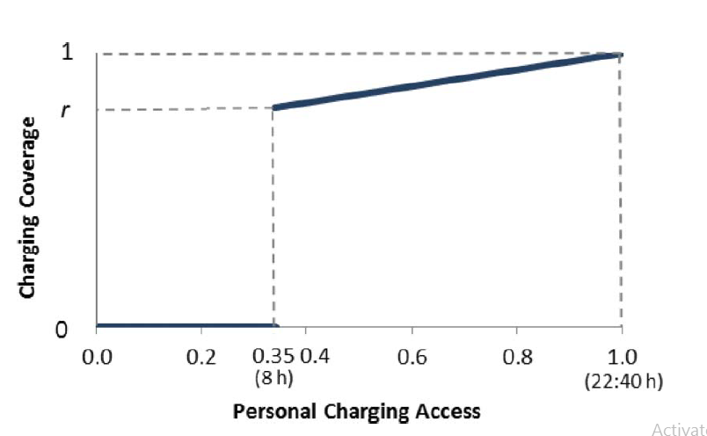

Figure 2.3 : Charging Coverage Function for = 0.35 (8 H).

**2.5. ADOPTION POTENTIAL**

It is highly unlikely that BEV will significantly replace ICE vehicles in a midterm perspective, but they are an attractive alternative to some small market segments with certain characteristics. These segments—the potential BEV buyers—are the target users for charging stations. The identification of the target users will allow determining charging station locations more favourable for the promotion of BEV. In this section, the relationship between the willingness to adopt BEV and the socioeconomic characteristics of populations is assessed based on a sample of studies available about such relationship. The assessment is performed through *the concept of adoption potential, which is defined as the likelihood of a given individual purchasing a BEV, thus becoming a user of charging stations*. Based on it, the differences in the willingness to adopt BEV can be appraised across different population groups.

There is useful market-related information available from studies dedicated to other alternative fuel vehicles or to cleaner or more efficient vehicles (hereafter jointly designated as environmentally friendly vehicles, EFV), that is, to vehicles with characteristics usually associated with BEV.

Ten studies were found where a significant relationship between the willingness to adopt EFV and some socioeconomic factors was observed. The factors most commonly considered in these studies are:

1. Education (ED),
2. Income (IN),
3. Gender (GE),
4. Age segment (AG),
5. Commuting distance (CD), and
6. Car ownership (CO)

Data for all these variables, except perhaps income, are easily available in many countries. The objects of study are different types of EFV. The studies analyze some of the factors mentioned, but no single study addresses all the factors simultaneously. Typically, they were conducted using regression techniques, linking the relative difference in the willingness to adopt EFV (expressed in percentage) with some discriminant conditions that individuals fulfill or not (like having college education or being of age between 25 and 44 years old). The overall conclusions from the majority of the studies are consistent. In particular, the same factors are found to be significant across studies and with similar impact on the willingness to adopt EFV (in the sense that the regression coefficients are similar). Below, we summarize the conclusions obtained for each factor.

* **EDUCATION**

The level of education is the socioeconomic factor more clearly linked to the willingness to adopt EFV. Many studies observed a significant positive relationship with this factor. Individuals with college education are 20% more likely to be interested in hybrid vehicles than the non-college population. It has been discussed that the importance of education level but did not engage in a quantitative analysis. Given these findings, it is reasonable to conclude that *population with college education is* ***20%*** *more likely to adopt BEV*.

* **INCOME**

The level of income appears also as a factor with a significant positive relationship with the willingness to adopt EFV, although with a level of impact slightly smaller than the one corresponding to education. The nature of the relationship varies, however, across studies.

It has been identified that a positive relation between the middle-income population and the preferences for alternative fuel vehicles. The definition of the middle-income segment differs according to the economy of the area under study. The impact level of this factor for the different studies varies between 11% and 22%. Given these findings, it is reasonable to conclude that population of the *middle- and high-income groups is* ***16%*** *more likely to adopt BEV.*

* **GENDER**

The gender of individuals is also identified as a significant characteristic in the willingness to adopt BEV but with a smaller level of impact than the rest of the socioeconomic factors. Studies has found that women have a stronger preference for fuel-efficient, electric, and alternative fuel vehicles than men. The impact levels are similar for these studies, with regression coefficients of a little less than a half of the ones obtained for education. Given these findings, it is reasonable to conclude that *women are* ***9%*** *more likely to adopt BEV.*

* **AGE SEGMENT**

The age of users is a factor also with a significant relationship with the willingness to adopt EFV, but not as strong as for the rest of the factors. It has been found that the whole 25–44 age group have a preference for clean vehicles 14% higher than the rest of the population. Given these findings, it is reasonable to conclude that *population from 25 to 44 years old is* ***14%*** *more likely to adopt BEV.*

* **CAR OWNERSHIP**

Most of these authors assign a similar level of importance to car ownership and education in the willingness to adopt EFV. Given the findings of the previous studies it is reasonable to conclude that *individuals living in a household with two or more vehicles are* ***20%*** *more likely to adopt BEV.*

The conclusions stated here with respect to the willingness to adopt BEV are summarized in

***Table-2.1***

Using the coefficients indicated there, and taking into account the fact that **education, income, and car ownership** typically are highly correlated, the BEV adoption potential for an individual I, ai, can be assessed through the following expression:

ai = EDi × GEi × AGi × CDi …………………(2.7)

Where:

EDi (or INi, or COi), GEi, AGi, and CDi are discrete variables that take the value of the adoption coefficient when the respective discriminant condition is met, or 1 otherwise.

**For example**, a 50-year-old woman (GE = 1.09, AG =1) with college education (ED = 1.20) and a commuting distance of 4 km (CD = 1) will have an adoption potential equal to 1.20 × 1.09 × 1 × 1 = 1.31 (using equation 2.7).

Expression (2.7) also applies to *population groups*, but in this case the variables refer to the proportion of individuals in the groups that full-fill the discriminant conditions in a given zone**.**

**For example**, if 30% of the population residing in zone i has college education, 45% are women, 25% are aged between 25 and 45 years old, and 80% commute more than 6 km to their work, the BEV adoption potential of zone i is:

1.06 ×1.0495 ×1.035 × 0.92 = 1.0593 ……… (using equation 2.7)

***As:***

EDi = 1.2 × 0.3 + 1 × 0.7 = 1.06;

GEi = 1.09 ×0.55 + 1 ×0.45 = 1.0495;

AGi = 1.14 × 0.25 + 1×0.75 = 1.035;

COi = 0.9 × 0.8 + 1 × 0.2 = 0.92

Table 2.1 : Adoption Potential Coefficients.

|  |  |  |
| --- | --- | --- |
| Factor | Discriminant Condition | Adoption Potential |
| Education | College education | 1.20 |
| Income | Middle or high income  groups | 1.16 |
| Gender | women | 1.09 |
| Age Segment | Age between 25 and 45 | 1.14 |
| Commute Distance | Commute distance higher than 6 km | 0.90 |
| Car Ownership | Two or more vehicles | 1.20 |

**Chapter-3**

***OPTIMIZATION FORMULATION TO OBTAIN OPTIMAL SITE AND SIZE OF ELECTRIC VEHICLE CHARGING STATIONS FOR NORTH-EAST CITY AGARTALA, TRIPURA, INDIA***

**3.1 INTRODUCTION**

The concepts of electric vehicle charging stations charging presented in previous chapter are now embodied into a location-allocation model that, once solved, determines the locations for a given number of charging stations that maximize the total charging coverage of the potential adopters of BEV. The proposed model, designated as Charging Station Covering Model (**CSCM**), can be classified as an un-capacitated gradual maximal covering model. The CSCM has an interesting new feature in the fact that coverage is sought for the combinations of places such as home, work, and other places where drivers park their cars over a day and not for each one of these places separately.

This feature makes the model more accurate but also clearly more complex. Possible capacity issues are not dealt with in the model so we have extended this model and result of this model will be used in next capacity optimisation model. The setting for application of the CSCM is a geographic area divided in small zones, such as census blocks or units.

**3.2 PROBLEM FORMULATION**

To obtain the optimal site and size of EVCSs, optimization problems are formulated considering equality and inequality constrains. Details about the optimization problem and simulation results for optimal site are given in section 3.2.1 and for optimal size of EVCSs are given in section 3.2.2 below:

**3.2.1 OPTIMIZATION PROBLEM FOR OBTAING OPTIMAL SITES OF CHARGING STATIONS**

* **DATA REQUIRED**

The data required to run the CSCM are the following:

* Population residing in zone i and working in zone j;
* Level of shopping and leisure activities in zone i;
* Adoption potential for the population residing in zone i (which depends on their socioeconomic characteristics);
* The possible charging station locations; and
* The walking distance between (the centroid of) each zone, i, and each possible location, s, for a charging station.
* **SETS**
* N : set of zones;
* G : set of population types (type 1 for population with a private garage; type 2 for

population without a private garage); and

* S : set of possible locations for charging stations.
* **PARAMETERS**

ai : adoption potential for population residing in zone i;

qijg : population of type g residing in zone i and working in zone j;

r : trade-off ratio (between drivers covered well enough and drivers fully covered);

tmin : potential charging needs expressed as a proportion of total daily parking time;

cis : coverage rate for zone i with a charging station located at s;

fH : average proportion of time spent at home;

fW : average proportion of time spent at work;

fO : average proportion of time spent at other places;

hijk : attractiveness index of zone k for individuals residing in zone i and working in zone j;

p : number of charging stations

**The decision variables are:**

zijg : charging coverage of population of type g residing in zone i and working in zone j;

xis = 1 if zone i is covered by a charging station located in zone s, otherwise xis = 0;

ys = 1 if a charging station is located in zone s, otherwise ys = 0;

wijg : personal charging access for population type g residing in zone i and working in zone j

vi : instant coverage of zone i;

vj : instant coverage of zone j;

mij : average instant coverage in places other than home or work for individuals residing in

zone i and working in zone j;

**OBJECTIVE FUNCTION:**

Max Z = ..….….…………... (3.1)

**SUBJECTED TO:**

xis  ys for all i N, sS ......….….………… (3.2)

..….….…………… (3.3)

..….….…………… (3.4)

..….….…………… (3.5)

..….….…………… (3.6)

..….….…………… (3.7)

..….….……………. (3.8)

.. ..….….…………… ..(3.9)

The objective function (3.1) of this optimization model defines the total potential charging coverage in the geographic area under study, obtained by adding (for all zones) the product of as following :

a*doption potential of the zone; the population residing in the zone distributed by their working zones (distinguishing between those who have a private garage, thus home charging, and those who have not); and the respective charging coverage*.

Constraints (3.2) to (3.4) determine the instant coverage of a zone.

According to Eq. (3.2), if a charging station is located at s (**ys**= 1), then zone i can be covered by s; otherwise it cannot (if **ys**= 0 then **xis**= 0).

The amount of coverage is given by Eq. (3.3), considering at most one charging station as stated by Eq. (3.4) (coverage by multiple charging stations in the same zone is not taken into account). Since the objective is to maximize coverage, the charging station which provides the highest coverage will automatically be retained in the model solution.

Constraints (3.5) and (3.7) refer to personal charging access. They define the expected proportion of daily parking time, **wijg**, individuals residing in zone i and working in zone j will be able to charge a BEV depending on whether they have a home charger [Eq. (3.5)] or not [Eq. (3.6)]. In periods where individuals are expected to be in zones other than home or work, access to charging stations is given by Eq. (3.7).

Constraints (3.3) determine the charging coverage for individualsresiding in zone i and working in zone j. According to Equation (3.3), if the charging access of individuals residing in zone i and working in zone j does not match at least their potential charging needs, then these individuals will not be covered.

Indeed, if **wijg < tmin** then, **zijg**= 0 (since **zijg**is binary) and, because of Eq. (3.4), **zijg**= 0.

If instead their charging access is greater than or equal to **tmin (wijg tmin),** then according to Eq. (3.7), **zijg** can be equal to 1 and **zijg** will be given by Eq. (3.8) as follows:

If **wij = tmin** then **zijg ≤ r** and, by maximization, **zijg = r**; if **wijg**= 1 then **zijg** < 1 and, by maximization, **zijg** = 1; and if **tmin < wijg < 1** then  **r < zijg < 1**.

Finally, constraint (3.9) specifies the number of charging stations to be installed (the number of **yS** variables that take the value of 1 cannot exceed p).

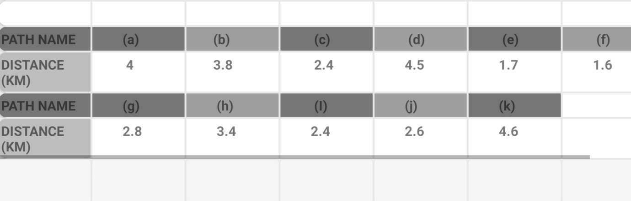

Table: 3.1 Path Distances

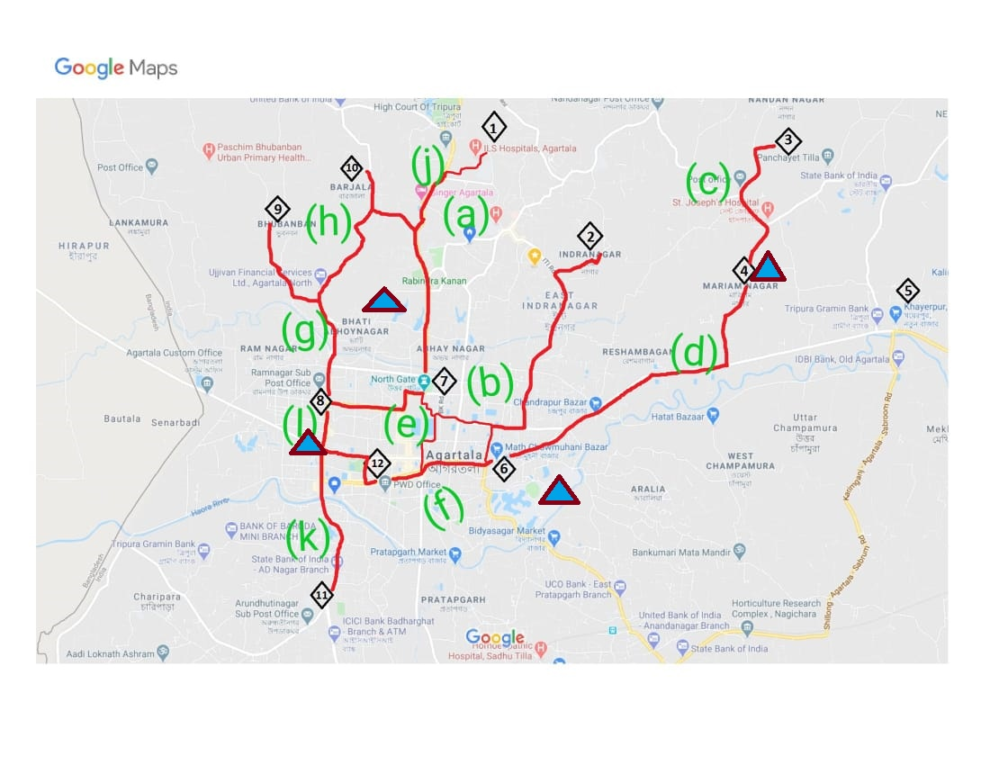

Fig 3.1: shows the road network of Agartala city

* **OPTIMIZATION RESULTS FOR CSCM**

The application of the charging station coverage model (CSCM) is exemplified below for a set of hypothetical instances. The setting for the instances considered is a specified area of Agartala of **5 km × 9km (45 km2) with a total working population of 2.57 Lakh.**

* The town is divided into 13 zones with centroids uniformly located at random across the urban area. The residences and jobs of the working population are uniformly distributed at random across the zones (their values were generated assigning random weights between 0 and 1 to each zone and then distributing the total working population of 2.7 Lakh across the zones according to those weights).
* Each centroid is a possible location for a charging station. The walking distances between zones are Euclidean.
* Full and maximum coverage distances are assumed to be 500 and 3 km, respectively.
* The average proportions of parking time spent at home, work, and other places are 62%, 25%, and 13%, respectively (i.e., the same average proportions as in Europe).
* The attractiveness index for the other places is assumed to be proportional to the sum of the number of residences with the number of jobs in each zone.
* The trade-off ratio is assumed to be 0.8 (that is, covering 10 drivers well is taken as equivalent to fully covering eight drivers) and the adoption potential is assumed to be the same in every zone.
* Also, residents are assumed to not have access to private garages.
* In this hypothetical example it is assumed that all population lives and works inside the study area (small town). However, population with some activity outside the area could easily be taken into account by adding two external zones, representing the external areas with and without access to charging stations. Both zones should be located far.
* Also assuming people of zone (3,5,6,7,8,11,12,13 ) are working in zone {7,12,13} since the no. of organizations are more in these three areas.

**We coded in *python using puLP modeller* and got the result as:**

|  |  |  |
| --- | --- | --- |
| *Adoption Potential =0.9* | *Adoption Potential = 1* | *Adoption Potential= 1*.14 |
| Status: Optimal | Status: Optimal | Status: Optimal |
| x10a = 0.0 | x10a = 0.0 | x10a = 0.0 |
| x10b = 0.0 | x10b = 0.0 | x10b = 0.0 |
| x10c = 0.0 | x10c = 0.0 | x10c = 0.0 |
| x11a = 0.0 | x11a = 0.0 | x11a = 0.0 |
| x11b = 0.0 | x11b = 0.0 | x11b = 0.0 |
| x11c = 0.0 | x11c = 0.0 | x11c = 0.0 |
| x12a = 1.0 | x12a = 1.0 | x12a = 0.0 |
| x12b = 0.0 | x12b = 0.0 | x12b = 0.0 |
| x12c = 0.0 | x12c = 0.0 | x12c = 0.0 |
| x13a = 0.0 | x13a = 0.0 | x13a = 0.0 |
| x13b = 0.0 | x13b = 0.0 | x13b = 0.0 |
| x13c = 1.0 | x13c = 1.0 | x13c = 1.0 |
| x1a = 0.0 | x1a = 0.0 | x1a = 0.0 |
| x1b = 0.0 | x1b = 0.0 | x1b = 0.0 |
| x1c = 0.0 | x1c = 0.0 | x1c = 0.0 |
| x2a = 0.0 | x2a = 0.0 | x2a = 0.0 |
| x2b = 0.0 | x2b = 0.0 | x2b = 0.0 |
| x2c = 0.0 | x2c = 0.0 | x2c = 0.0 |
| x3a = 0.0 | x3a = 0.0 | x3a = 0.0 |
| x3b = 0.0 | x3b = 0.0 | x3b = 0.0 |
| x3c = 1.0 | x3c = 1.0 | x3c = 1.0 |
| x4a = 0.0 | x4a = 0.0 | x4a = 0.0 |
| x4b = 0.0 | x4b = 0.0 | x4b = 0.0 |
| x4c = 0.0 | x4c = 0.0 | x4c = 0.0 |
| x5a = 0.0 | x5a = 0.0 | x5a = 0.0 |
| x5b = 0.0 | x5b = 0.0 | x5b = 0.0 |
| x5c = 1.0 | x5c = 1.0 | x5c = 1.0 |
| x6a = 1.0 | x6a = 1.0 | x6a = 0.0 |
| x6b = 0.0 | x6b = 0.0 | x6b = 0.0 |
| x6c = 0.0 | x6c = 0.0 | x6c = 0.0 |
| x7a = 1.0 | x7a = 1.0 | x7a = 0.0 |
| x7b = 0.0 | x7b = 0.0 | x7b = 0.0 |
| x7c = 0.0 | x7c = 0.0 | x7c = 0.0 |
| x8a = 0.0 | x8a = 0.0 | x8a = 0.0 |
| x8b = 1.0 | x8b = 1.0 | x8b = 0.0 |
| x8c = 0.0 | x8c = 0.0 | x8c = 0.0 |
| x9a = 0.0 | x9a = 0.0 | x9a = 0.0 |
| x9b = 0.0 | x9b = 0.0 | x9b = 0.0 |
| x9c = 0.0 | x9c = 0.0 | x9c = 0.0 |
| ya = 1.0 | ya = 1.0 | ya = 1.0 |
| yb = 1.0 | yb = 1.0 | yb = 1.0 |
| yc = 1.0 | yc = 1.0 | yc = 1.0 |
| **Coverage = 0.883463** | **Coverage = 0.9816256000** | **Coverage = 0.9990894** |

And the feasible location is marked as blue triangle:

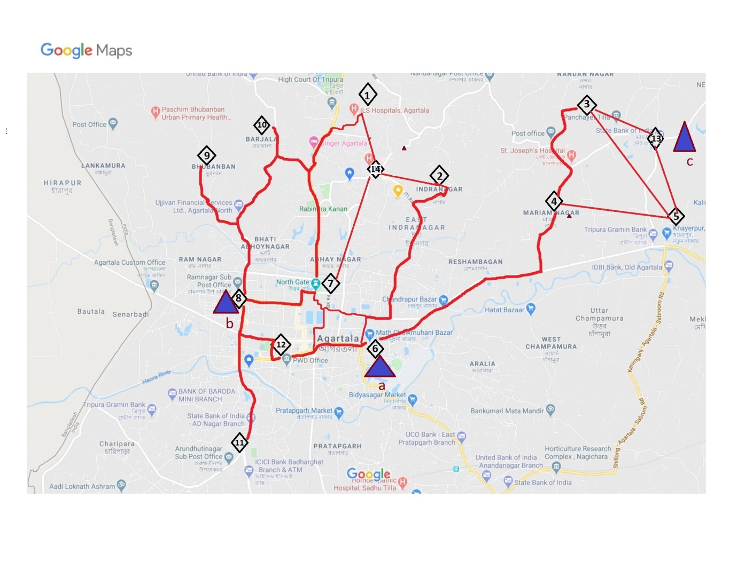

Figure 3.2: Optimised Location of EVCSs

Table 3.2: Coverage output with varying Adoption Potential

|  |  |  |
| --- | --- | --- |
| **Coverage (%)** | **Adoption Potential** | **population =p*20K** |
| 88.34 | 0.9 | 0.08 |
| 98.16 | 1 | 0.08 |
| 98.9 | 1.14 | 0.08 |
| 99.77 | 1.2 | 0.08 |
| 99.94 | 1.16 | 0.08 |

**3.2.2 OPTIMIZATION PROBLEM FOR OBTAINING OPTIMAL SIZE OF EVCSS**

This section discusses recent approaches that have been proposed in different research works in order to find the optimal placement and capacity of the Charging Stations (CSs) in urban areas based on the total expected cost that result from CS development cost, EV user cost, and grid power cost. A new approach to determine the optimal location and capacity of fast charging stations has been proposed. The problem has been formulated as a programming problem to reduce the total expected cost for EV charging.

CS Development, and the expected cost incurred by EV drivers, and grid operator due to the charging process have been included in the zonal based approach. The EV drivers’s behaviour is also taken into account, in order to estimate the charging demand, and the expected of the EV drivers’ cost. Specifically, the study area has been divided in to many zones to determine the CS location and EV positions and the EVs in each district are distributed among these zones.

The zonal EV population, charging demand, EV driver cost, station development cost, and grid operator cost have been calculated using objective function (1). This paper did not consider the terrain features, and the weather in the parameters that can affect the location of the charging stations, since the EV energy consumption is affected by both of them. We have not considered the available spaces for the charging stations before distribution the candidate charging stations. This approach was implemented in small area, and with small numbers of EVs, so we are not sure about the effectiveness of the approach in wide area, and with large number of EVs.

We have focused on increasing the coverage of PEV within the desired distance service, but have not considered the economic issues that may affect a CSs selection, such as a land price, and build-up cost of the CSs. The availability of the space for the candidate CSs, grid power losses, road traffic density have not taken into account in this paper. We did not consider many factors, such as variety in electricity prices, climate change, the number of the connectors at each CS, the number of the EVs in a queue at each CS, and the free spaces that can be designated for candidate CSs.

* **PROBLEM DESCRIPTION**

Let us formulate this problem as a mathematical optimization model. In this study, the charging stations are built within the road network. EV users choose the shortest way from the nodes of road network to any charging stations. So accordingly, a number of chargers can be deployed based on full use of capacity.

* **VARIABLES DEFINITION**

I: set of zones

J: set of charging station

yj: Binary variable which assumes a value of 1 if facility at location j J , is open and 0 otherwise.

fj: set up cost of a CS at location j

xij: fraction of demand supplied by a CS at location j to zone i

cij: cost of serving zone i from a CS located at j

* **OBJECTIVE FUNCTION**

The objective function is to minimize the integrated cost of investment and operation, as shown in equation 6.1

*MIN C = TDC + TOC + TGC …………………………* (3.10)

Where:

* TDC represents the station development Cost,
* TOC denotes the EV User Cost, and
* TGC is the grid operator Cost.

We have taken: TDC + TGC =

Consider n zones, i =1,2…… up-to n, and m sites for CSs  j = 1,2,… up-to m.

Define continuous variables **xij**≥ 0 as the amount serviced from facility j to demand point i, and binary variables **y**j = 1 if a facility is established at location j, **yj**=0 otherwise.

An integer-optimization model for the capacity of charging station problem can now be specified as follows:

**Minimize +**  ……*………………*(3.11)

The objective of the problem is to minimize the sum of charging station activation costs and EV user cost to access the charging facility.

* **CONSTRAINTS**

Subjected to:

**ij** = 1 for all i I …………………… (3.12)

**xij** yi for all i I, jJ …………………… (3.13)

**xij** 0 for all i I, j J …………………… (3.14)

**yj** {0, 1} for all j J ….………………… (3.15)

This paper assumes that at most one charging station can be built on one close part of a road and the station must be built within the range of the road. The sum of the charging demand on each node should be equal to the sum of charging capacity of each charging station.

The capacity of each charging station also has a certain upper and lower bound. For this model, the invested capacity is based on the number of chargers in a charging station. For capacity of all the charging stations on the road, they should meet the following two constraints:

*Situation 1*: When a candidate charging station is selected, the number of the chargers meets the upper and lower constrain

*Situation 2*: When a candidate charging station is not selected, the number of chargers is zero.

Table 3.3: Data of Agartala

|  |  |
| --- | --- |
| **Items** | **Data** |
| Size (square KM) | 45 |
| Population (in Lakh) | 2.27 |

We have considered a selective area of 45 km2. According to the city zoning map and actual administrative road map, this paper simplifies the structure of the road network in Agartala,, as shown in Figure 3.2.

**3.2.3 SOLVING PROPOSED FORMULATION**

We used the python language with puLP modeller to solve this optimisation problem

The code is as:

|  |
| --- |
| #importing puLP modeller  from pulp import *  # Creates a list of all the charging stn.  CS = ["a",  "b",  "c"  ]  cpcost = { "a":[20, 70000],  "b" :[20, 70000],  "c" :[20, 65000]  }  zones = ["3", "5", "6", "7", "8", "12", "13"]  demand = { #zones Demand  "3" :18,  "5" : 10 ,  "6" :10 ,  "7" : 2,  "8" : 10,  "12" :10 ,  "13" : 10,  }  costs = [ #zones  #3 #5 #6 #7  [82, 75, 5, 20, 37, 16, 112], #a  [4119, 112, 37, 17, 5, 24, 149],#b Plants  [30, 25, 112, 132, 149, 128, 5], #c  ]  Routes = [(p, s) for p in Plants for s in zones]  (supply, fixedCost) = splitDict(cpcost)  costs = makeDict([Plants, zones], costs, 0)  flow = LpVariable.dicts("Route",(Plants,ones),0,None,LpInteger)  build = LpVariable.dicts("Build charging station ",Plants,0,1,LpInteger)  prob = LpProblem("Charging station Problem",LpMinimize)  prob += lpSum([flow[p][s]*costs[p][s] for (p,s) in Routes])+lpSum([fixedCost[p]*build[p] for p in Plants]),"Total Costs"  for p in Plants:  prob += lpSum([flow[p][s] for s in zones]) <= supply[p]*build[p], ("Sum of chargers out of Plant %s"%p)  for s in Nodes:  prob += lpSum([flow[p][s] for p in Plants]) >= demand[s], ("Sum of chargers into zones %s" %s)  # The problem is solved using PuLP's choice of Solver  prob.solve()  # The status of the solution is printed to the screen  print("Status:", LpStatus[prob.status])  # Each of the variables is printed with it's resolved optimum value  for v in prob.variables():  print(v.name,"=",v.varValue)  # The optimised objective function value  print("Total Costs = ", value(prob.objective)) |

**3.3 OPTIMIZATION RESULTS:**

**Status: Optimal**

Build_aPlant_a = 1.0

Build_aPlant_b = 1.0

Build_aPlant_c = 1.0

Route_a_12 = 10.0

Route_a_13 = 0.0

Route_a_3 = 5.0

Route_a_5 = 5.0

Route_a_6 = 5.0

Route_a_7 = 0.0

Route_a_8 = 0.0

Route_b_12 = 0.0

Route_b_13 = 0.0

Route_b_3 = 0.0

Route_b_5 = 0.0

Route_b_6 = 0.0

Route_b_7 = 10.0

Route_b_8 = 5.0

Route_c_12 = 0.0

Route_c_13 = 10.0

Route_c_3 = 0.0

Route_c_5 = 0.0

Route_c_6 = 0.0

Route_c_7 = 0.0

Route_c_8 = 0.0

**Total Costs ($)** = 217150.0

Where Route_c_13 = 10 stands for: charging station to zone to be covered we need 10 chargers at c.

The results in the table above show that charging stations are almost built at nodes and constructed stations reach the maximum number. This is because the needs of users are at nodes. The closer the stations are to the nodes, the more the cost of charging can be reduced. With more sites and more dispersion, it will be more conducive to the user's convenience, reduce the cost, but will increase the fixed cost of the construction of the station.

ss

**3.5 RESULT ANALYSIS**

It can be seen from the results that the charging stations are mostly concentrated on a few road nodes with large Vehicle running hour. This is because the closer the charging stations are to the nodes, the less the time and energy costs are. With the reduction of total capacity and number of charging stations, fewer charging stations will be built. Then EV users need to go through a longer distance to the station for charging, resulting in higher overall costs.

**Chapter - 4**

# CONCLUSION

Allocation model derived from a detailed analysis of BEV charging needs, charging coverage, and adoption potential. This model can be classified as a gradual maximal covering model because, above a given distance, the coverage rate provided by charging stations is assumed to decrease gradually, as the distance from users increases. An interesting new feature of the model is the fact that coverage is sought for the combinations of places (home, work, and other places) where drivers park their cars over a day, and Electric vehicles need particular charging facilities to access the grid. This paper proposes an optimization process of the optimal siting and sizing of EV charging stations. The approach relies on an innovative location not for each one of these places separately. This makes the model more accurate but also more complex and clearly more difficult to solve. The model underlying the proposed approach was tested on a set of hypothetical instances replicating the essential ingredients of real world problems, and its results were compared with the results obtained through a classic gradual maximal covering model. The conclusion was that, on average, the charging coverage provided by the new model is 95% higher depending on the number of charging stations installed and the adoption potential.

Case study shows that the proposed method can effectively reduce the investment and operation costs of electric vehicle charging stations, and facilitate users to charge. Further work in this area of research will concentrate on a real case study involving the city Though this is a relatively small area of city. in order to properly represent the charging station location problem there, the urban area has to be divided in hundreds of zones. Given the computational effort required to run the model using an optimization solver.

## 

**REFERENCES**

[1] Diego A. Giménez-Gaydou, Anabela S. N. Ribeiro, Javier Gutiérrez & António Pais Antunes (2016) Optimal location of battery electric vehicle charging stations in urban areas: A new approach, International Journal of Sustainable Transportation, 10:5, 393-405, DOI: 10.1080/15568318.2014.961620.

[2] Long JIA, Zechun HU, Member, IEEE, Yonghua SONG, Fellow, IEEE and Zhuowei Luo, Optimal Siting and Sizing of Electric Vehicle Charging Stations, IEEE, Article: March 2012 DOI: 10.1109/IEVC.2012.6183283.

[3] Mincong Tang, Beijing Jiaotong University Xiaochun Lu, Beijing Jiaotong University Finding Key Factors Affecting the Locations of Electric Vehicle Charging Stations: a Simulation and ANOVA Approach Article in International Journal of Simulation Modelling · September 2017 DOI: 10.2507/IJSIMM16(3) CO15.

[4] Dr. Mehrnaz Ghamami (PI), Michigan State University Electric Vehicle Charger Placement Optimization in Michigan: Phase I – Highways, February 13, 2019.

[5] Mohammad Aljaidi, Nauman Aslam, Omprakash Kaiwartya, Optimal Placement and Capacity of Electric Vehicle Charging Stations in Urban Areas: Survey and Open Challenges, IEEE JEEIT, DOI:978-1-5386-7942-5/19/$31.00 ©2019.

[6] Berman, O., Drezner, Z., & Krass, D. (2010). Generalized coverage: New developments in covering location models. Computers and Operations Research, 37(10), 1675–1687.

[7] Berman, O., Krass, D., & Drezner, Z. (2003). The gradual covering decay location problem on a network. European Journal of Operational Research, 151(3), 474–480.

[8] Bersani, C., Minciardi, R., Sacile, R., & Trasforini, E. (2009). Network planning of fuelling service stations in a near-term competitive scenario of the hydrogen economy. Socioeconomic Planning Sciences, 43(1), 55–71.

[9] Botsford, C., & Szczepanek, A. (2009, May). Fast charging vs. slow charging: Pros and cons for the new age of electric vehicles. In EVS-24 .

[10] International Battery, Hybrid and Fuel Cell Electric Vehicle Symposium. Symposium conducted at the meeting of the International Electric Vehicle Symposium and Exposition of Stavanger, Norway.

[11] Boulanger, A. G., Chu, A. C., Maxx, S., & Waltz, D. L. (2011). Vehicle electrification: Status and issues. Proceedings of the IEEE, 99(6), 1116–1138.

[13] Brownstone, D., Bunch, D. S., & Train, K. (2000). Joint mixed logit models of stated and revealed preferences for alternative-fuel vehicles. Transportation Research Part B: Methodological, 34(5), 315–338.

[14] Brownstone, D., & Train, K. (1998). Forecasting new product penetration with flexible substitution patterns. Journal of Econometrics, 89(1–2), 109–129.

[15] Burke, A. F. (2007). Batteries and ultracapacitors for electric, hybrid, and fuel cell vehicles. Proceedings of the IEEE, 95(4), 806–820.

[16] Chan, C. C. (2002). The state of the art of electric and hybrid vehicles. Proceedings of the IEEE, 90(2), 247–275.

[17] Chan, C. C. (2007). The state of the art of electric, hybrid, and fuel cell vehicles. Proceedings of the IEEE, 95(4), 704–718.

[18] Church, R., & ReVelle, C. (1974). The maximal covering location problem. Papers in Regional Science, 32(1), 101–118.

[19] Daskin, M. (2008). What you should know about location modeling. Naval Research Logistics (NRL), 55(4), 283–294.

[20] Eberle, D. U., & Von Helmolt, D. R. (2010). Sustainable transportation based on electric vehicle concepts: A brief overview. Energy and Environmental Science, 3(6), 689–699.

[21] EC. (2011, 28 March). Roadmap to a single European transport area: Towards a competitive and resource efficient transport system (White Paper No. COM (2011) 144 final). Brussels, Belgium: European Commission.

[22] EEA. (2010). The European environment: State and outlook 2010: Synthesis. Luxembourg: European Environment Agency, Publications Office of the European Union.

[23] EEA. (2012). The contribution of transport to air quality, TERM 2012: Transport indicators tracking progress towards environmental targets in Europe (No. 10/2012). Luxembourg: European Environment Agency.

[24] EP. (2013, 26 November). Alternative fuel stations: Transport Committee backs draft law to expand networks (Press Release). Brussels, Belgium: European Parliament.

[25] Erdem, C., ¸Sent€urk, _I; & ¸Sim¸sek, T. (2010). Identifying the factors affecting the willingness to pay for fuel-efficient vehicles in Turkey: A case of hybrids. Energy Policy, 38(6), 3038–3043.

[26] Eurostat. (2004). European time use survey: How is the time of Europeans distributed? Luxembourg: Eurostat Press Office.

[27] Eurostat. (2007). Passenger mobility in Europe: Statistics in focus. Luxembourg: Office for Official Publications of the European Communities, European Commission.

[28] Frade, I., Ribeiro, A., Gon¸calves, G., & Antunes, A.P. (2011). Optimal location of charging stations for electric vehicles in a neighborhood in Lisbon, Portugal. Transportation Research Record, 2252(1): 91–98.

[29] Furth, P. G., & Rahbee, A. B. 2000. Optimal bus stop spacing through dynamic programming and geographic modeling. Transportation Research Record: Journal of the Transportation Research Board, 1731 (1), 15–22.

[30] Guti_errez, J., Cardozo, O. D., & Garc_ıa-Palomares, J. C. (2011). Transit ridership forecasting at station level: An approach based on distance decay weighted regression. Journal of Transport Geography, 19(6), 1081–1092.

[31] Guti_errez, J., & Garc_ıa-Palomares, J. C. (2008). Distance-measure impacts on the calculation of transport service areas using GIS. Environment and Planning B: Planning and Design, 35(3), 480–503.

[32] Hansen, P., & Mladenovi_c, N. (2001). Variable neighborhood search: Principles and applications. European Journal of Operational Research, 130, 449–467.

[33] Hansen, P., Mladenovi_c, N., Brimberg, J., & Moreno-P_erez, J. A. (2010). Variable neighborhood search. In Handbook of Metaheuristics (2nd ed., pp. 61–86). London, UK: Springer.

[34] Horner, M. W., & Murray, A. T. (2004). Spatial representation and scale impacts in transit service assessment. Environment and Planning B: Planning and Design, 31(5), 785–797.

[35] IEA. (2013, April). Global EV outlook: Understanding the electric vehicle landscape to 2020. Paris, France: IEA.

[36] Kuby, M., & Lim, S. (2006). Location of alternative-fuel stations using the flow-refueling location model and dispersion of candidate sites on arcs. Networks and Spatial Economics, 7(2), 129–152.

[37] Kurani, S., Turrentine, T., & Sperling, D. 1996. Testing electric vehicle demand in “hybrid households” using a reflexive survey. Transportation Research Part D: Transport and Environment, 1(2), 131–150.

[38] Mak, H.-Y., Rong, Y., & Shen, Z.-J. M. (2013). Infrastructure planning for electric vehicles with battery swapping. Management Science, 59, 1557–1575.

[39] Mart_ınez, L. M., & Viegas, J. M. (2013). A new approach to modelling distance- decay functions for accessibility assessment in transport studies. Journal of Transport Geography, 26, 87–96.

[40] McCarthy, P. S., & Tay, R. S. (1998). New vehicle consumption and fuel efficiency: a nested logit approach. Transportation Research Part E: Logistics and Transportation Review, 34(1), 39–51.

[41] Murray, A. T. (2001). Strategic analysis of public transport coverage. Socioeconomic Planning Sciences, 35(3), 175–188.

[42] Potoglou, D., & Kanaroglou, P. S. (2007). Household demand and willingness to pay for clean vehicles. Transportation Research Part D: Transport and Environment, 12(4), 264–274.

[43] ReVelle, C. S., & Eiselt, H. A. (2005). Location analysis: A synthesis and survey. European Journal of Operational Research, 165(1), 1–19.

[44] Sangkapichai, M., & Saphores, J.-D. (2009). Why are Californians interested in hybrid cars? Journal of Environmental Planning and Management, 52(1), 79–96.

[45] Skippon, S., & Garwood, M. (2011). Responses to battery electric vehicles: UK consumer attitudes and attributions of symbolic meaning following direct experience to reduce psychological distance. Transportation Research Part D: Transport and Environment, 16(7), 525–531.

[46] Snyder, L. V. (2011). Covering problems. In H. A. Eiselt & V. Marianov (Eds.), Foundations of location analysis (pp. 109–135). London,UK: Springer.